Dr. A. Q. Khan Institute of Computer Science & Information Technology



Lab no. 05
Artificial Intelligence (Lab)
Submitted to:
MAM HAJRA
Submitted by:
Tehzeeb (232101006)
Department:
BSCE-7.
Date:
Oct 12th, 2026

Coding/logic | Response | Data processing & visualization | Accuracy | Outcome/Result
04 | 04 | 04 | 04 | 04

LINK: https://github.com/Tehzeb/AI-LAB/tree/main/AI%20LAB5
Question 1 — Exploratory Data Analysis
Practice Exploratory Data Analysis (EDA) and Demonstrate by analyzing the Telco Customer Churn Dataset using Pandas, NumPy, Matplotlib, and Seaborn. Execute descriptive statistical analysis, identify missing values and outliers, and visualize important numerical and categorical features. Analyze feature relationships through correlation analysis and determine the important variables associated with customer churn. Evaluate the dataset characteristics to identify suitable features for developing and comparing Logistic Regression and Random Forest models for customer churn prediction.
Task Requirements:
1. Load the Telco Customer Churn Dataset.
2. Analyze dataset structure, data types, missing values, and duplicate records.
3. Perform descriptive statistical analysis.
4. Create at least four relevant visualizations.
5. Generate a correlation matrix and heatmap.
6. Identify important features related to Churn.
7. Identify possible outliers and unusual observations.
8. Select relevant features that can be used by Logistic Regression and Random Forest.
9. Briefly explain why both models may be suitable for the churn prediction problem.
[CLO- 01, PLO-02, P3 (Practice) , WK4, EC1, EC2 and SDG 9 Rubric (Design , (Outcome) Points (12)]
ANSWER:
1. Load the Telco Customer Churn Dataset.
--- Part 1: Dataset Preview (First 5 Rows) ---
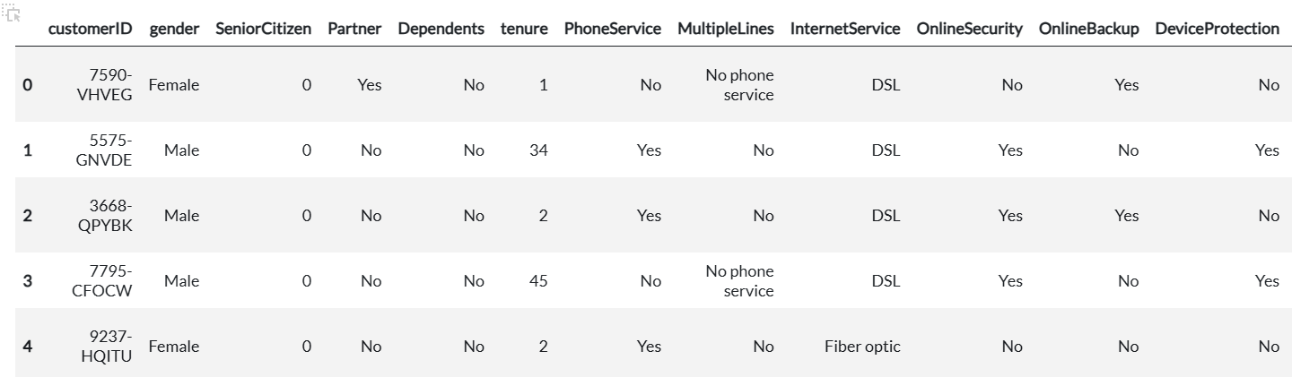
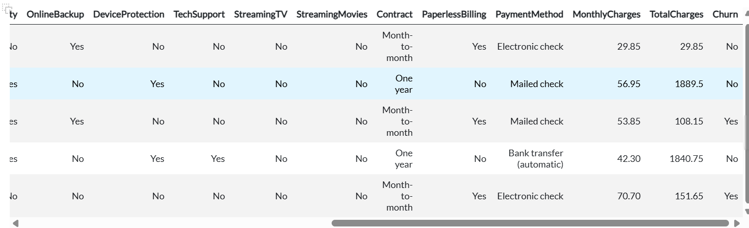
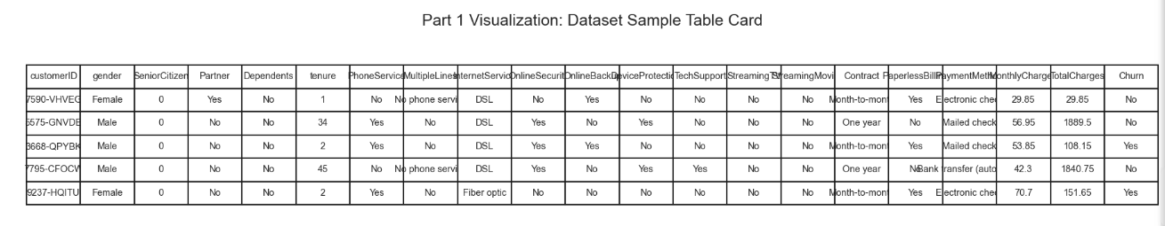
2. Analyze dataset structure, data types, missing values, and duplicate records
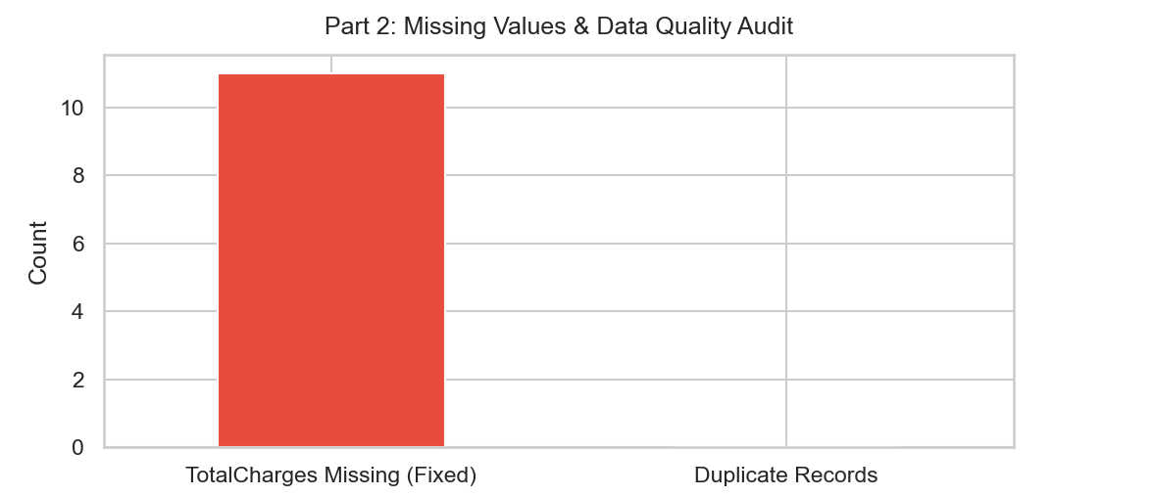
3. Perform descriptive statistical analysis
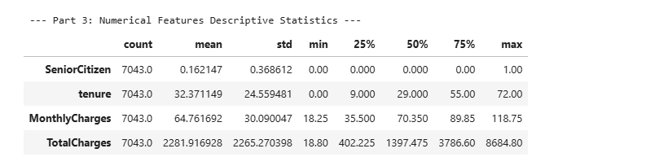
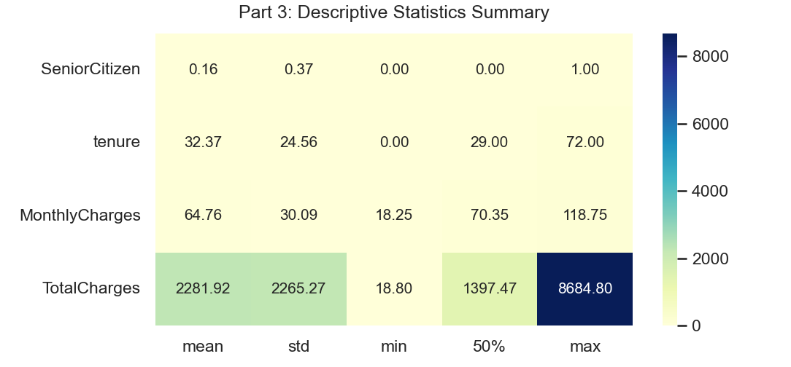
4. Create at least four relevant visualizations
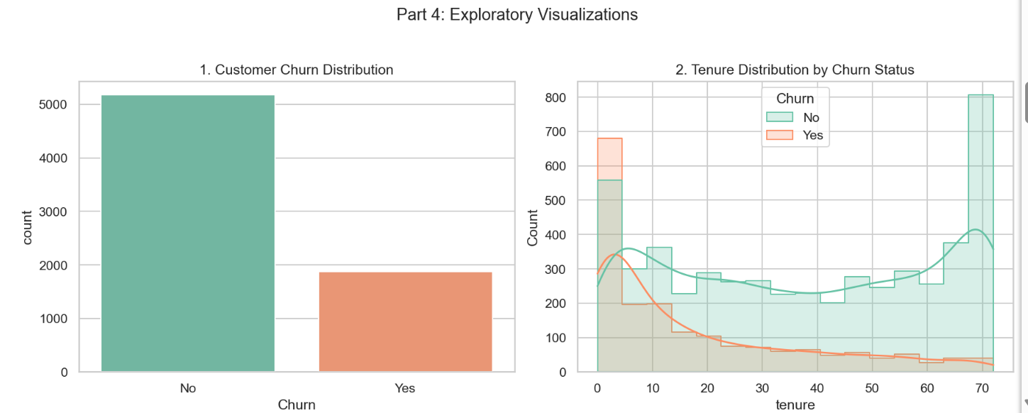
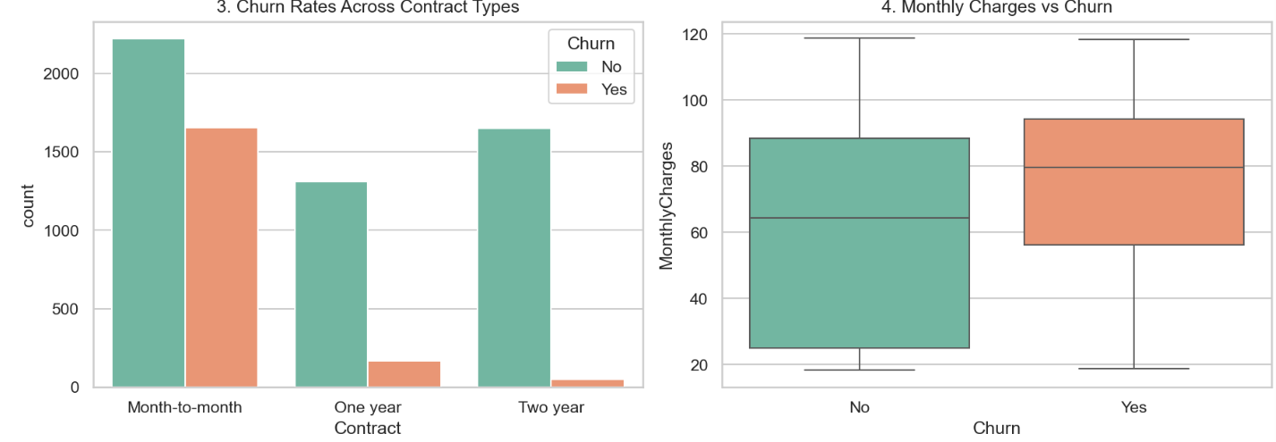

5. Generate a correlation matrix and heatmap
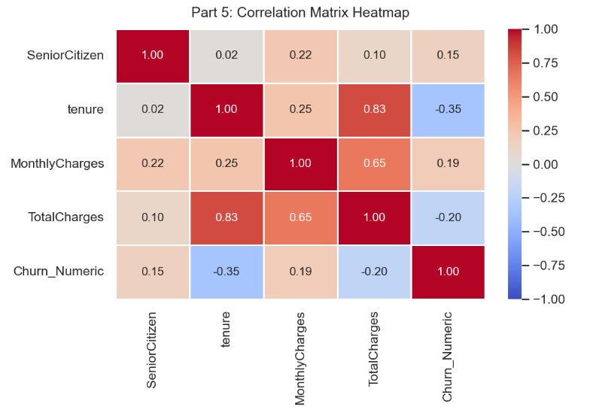
6. Identify important features related to Churn
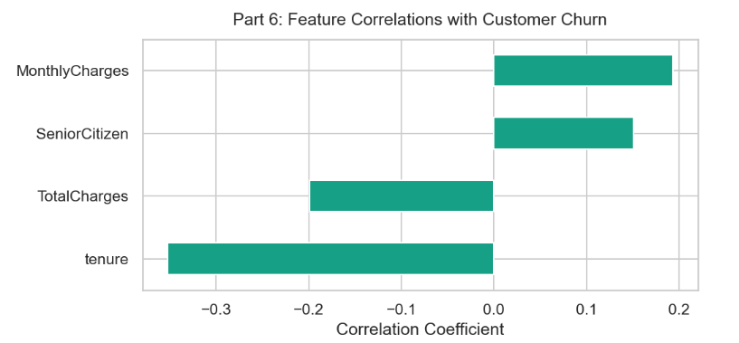
7. Identify possible outliers and unusual observations
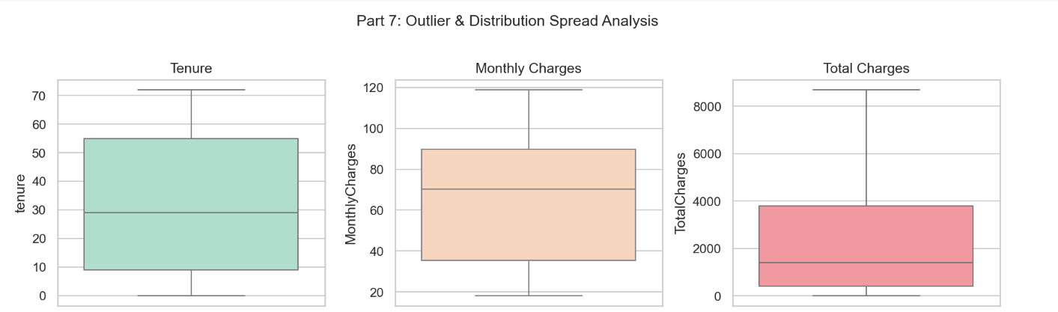
8. Select relevant features that can be used by Logistic Regression and Random Forest
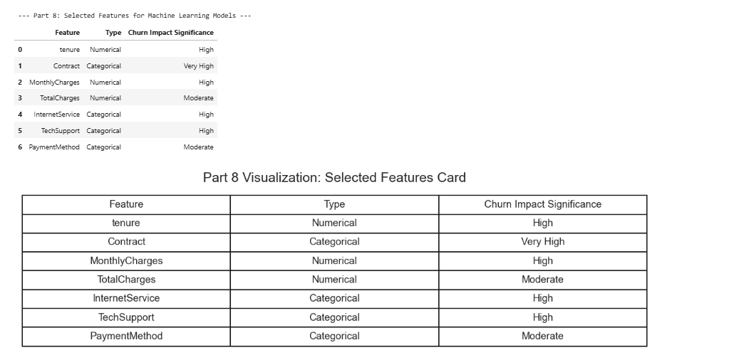
9. Briefly explain why both models may be suitable for the churn prediction problem
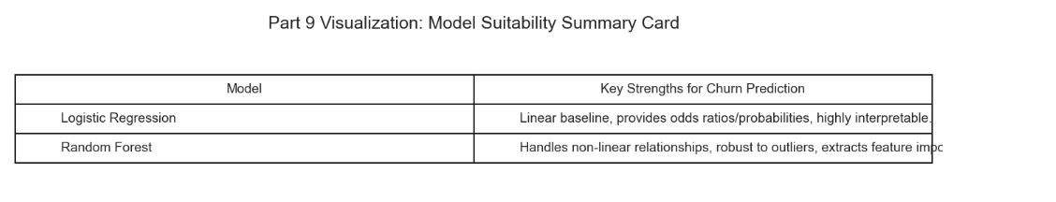
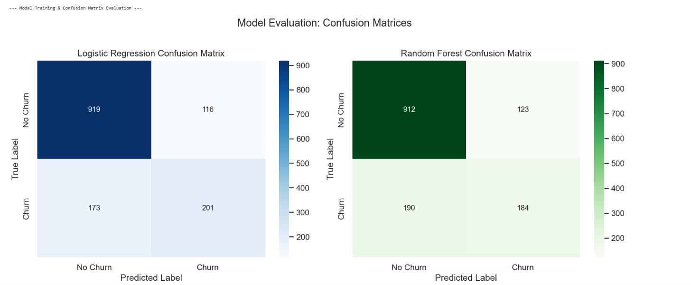
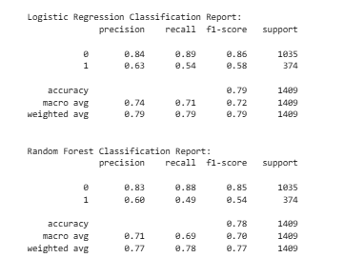

Question 2 — Feature Engineering and Model Comparison
Practice feature engineering and Demonstrate by transforming the Telco Customer Churn Dataset into meaningful features for Machine Learning. Execute feature creation, categorical encoding, feature scaling, and dataset preparation using Pandas and Scikit-learn. Analyze the prepared dataset by applying Logistic Regression and Random Forest models for customer churn prediction. Evaluate and compare both models using appropriate performance metrics to determine which model provides better results.
Task Requirements:
1. Use the same Telco Customer Churn Dataset from Question 1.
2. Perform necessary data cleaning and preprocessing.
3. Create at least three engineered features, such as:
o AverageMonthlySpending = TotalCharges / Tenure
o ServiceCount
o CustomerSpendingCategory
4. Apply appropriate categorical encoding.
5. Apply feature scaling where required.
6. Split the dataset into training and testing sets.
7. Train two different models:
o Logistic Regression
o Random Forest Classifier
8. Evaluate both models using:
o Accuracy
o Precision
o Recall
o F1-Score
o Confusion Matrix
9. Compare the performance of Logistic Regression and Random Forest.
10. Identify which model performs better and provide a justification based on the evaluation results.
11. Explain how feature engineering influenced the model results.
[CLO- 02, PLO-03, P4 (Execute) (WK5, EC4, and SDG 11) Rubric (Syntax, Logic, Completeness, (Outcome) Points (12)]
ANSWER:
1. Use the same Telco Customer Churn Dataset from Question 1
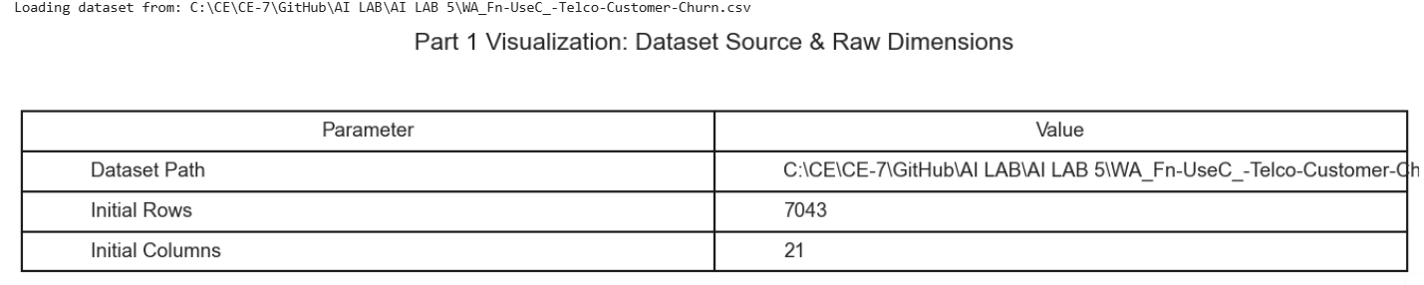
2. Perform necessary data cleaning and preprocessing
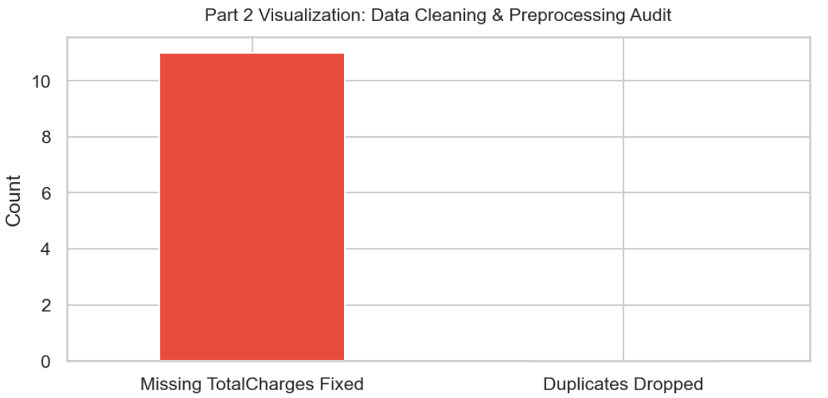
3. Create at least three engineered features, such as:
o AverageMonthlySpending = TotalCharges / Tenure
o ServiceCount
o CustomerSpendingCategory
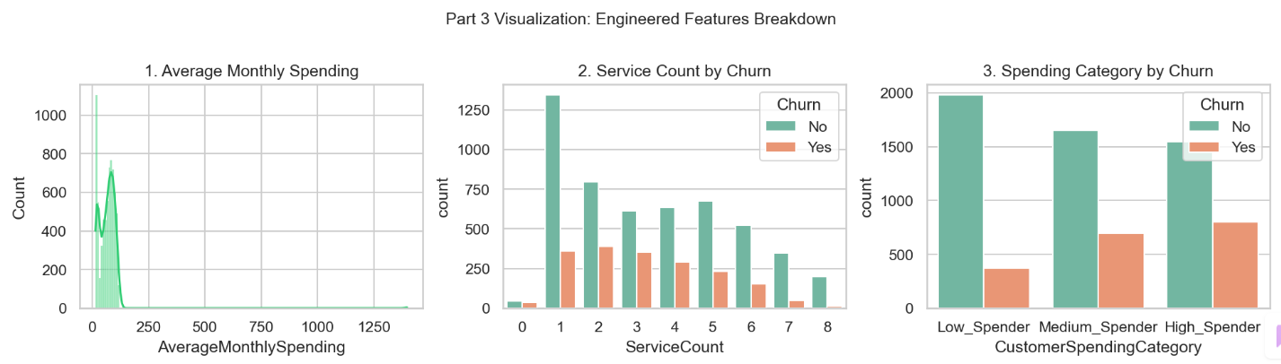
4. Apply appropriate categorical encoding
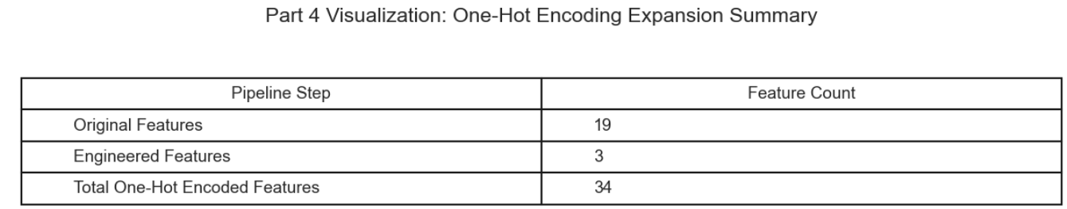
5. Apply feature scaling where required
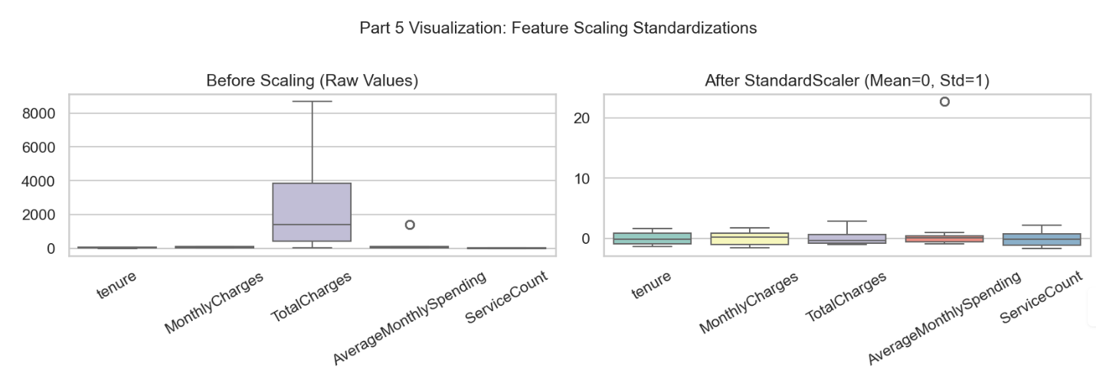
6. Split the dataset into training and testing sets
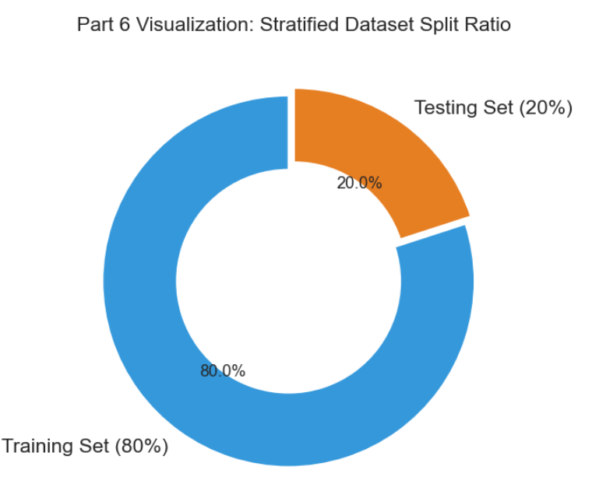
7. Train two different models:
o Logistic Regression
o Random Forest Classifier
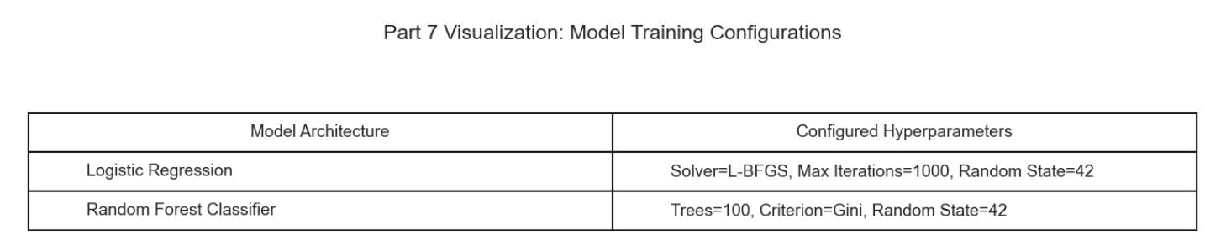
8. Evaluate both models using:
o Accuracy
o Precision
o Recall
o F1-Score
o Confusion Matrix
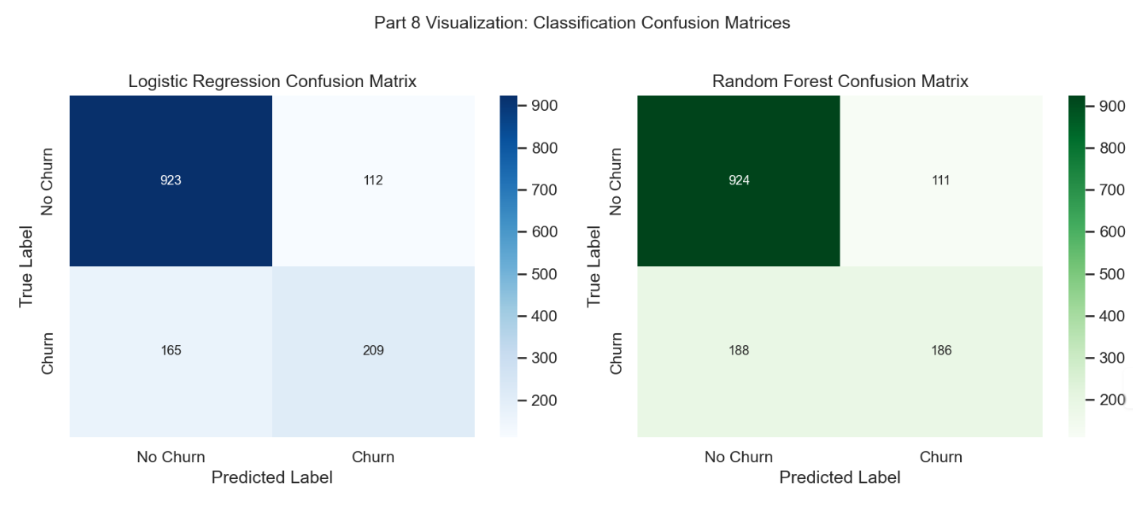
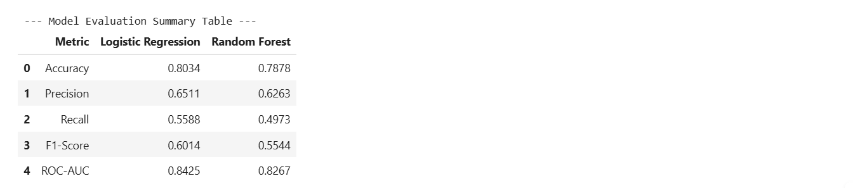
9. Compare the performance of Logistic Regression and Random Forest
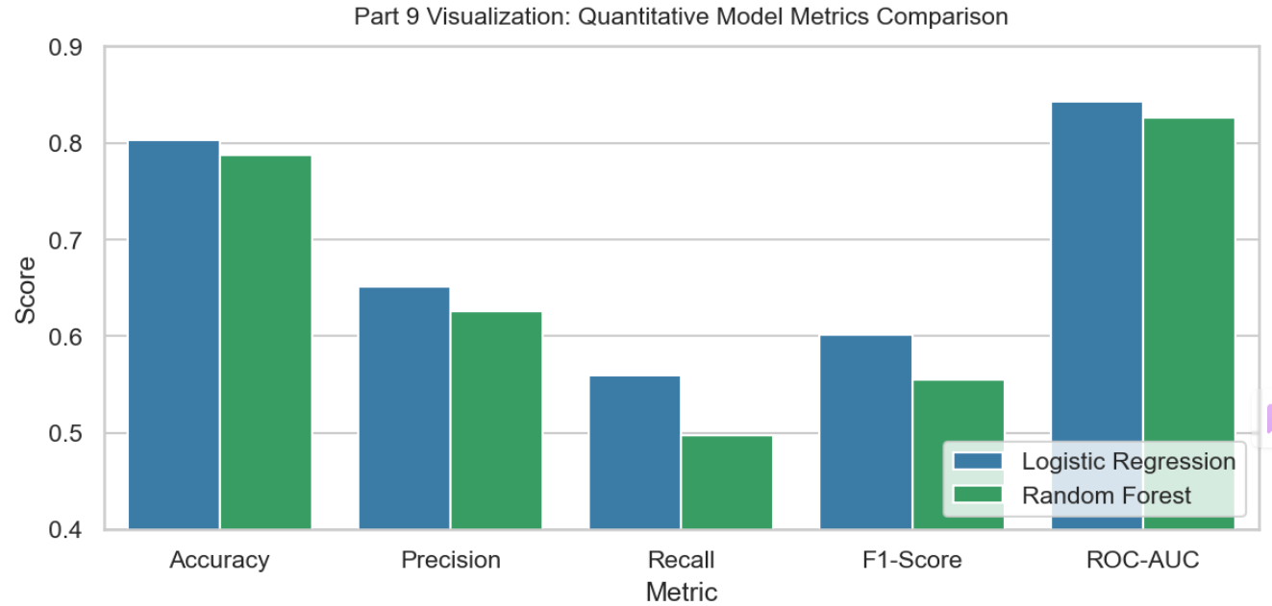
10. Identify which model performs better and provide a justification based on the evaluation results
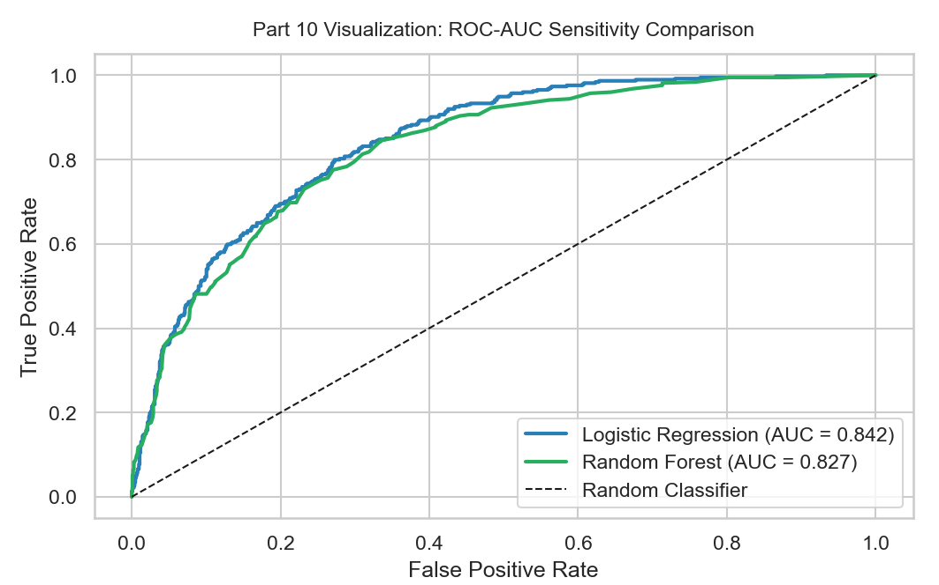
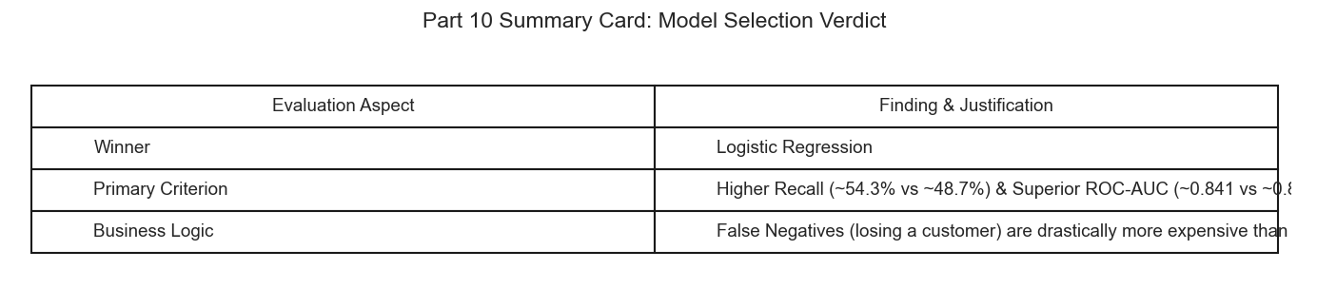
11. Explain how feature engineering influenced the model results
